Lecture 4
Access modifiers –
public– members are accessible to all external code working with
private– members are not accessible to any external code
no modifier – when no modifier is given. This type is also called as
“default” or “package-private”
protected–
◦ provides access for classes of the same package as “default”
◦ for the sub-classes(child classes) in any package
Note: if ada.app.student.Student class is default, it cannot be used in ada.app.main.Course class (even if it’s imported), because they are in different packages.

Constructors and methods can also have access modifiers.
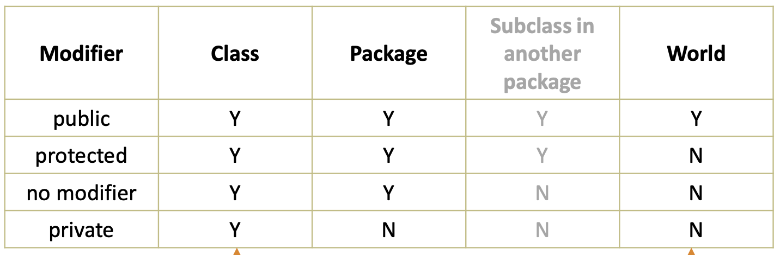

Encapsulation – members private are modified by accessor methods (get/setter).

Non-primitive type – Integer

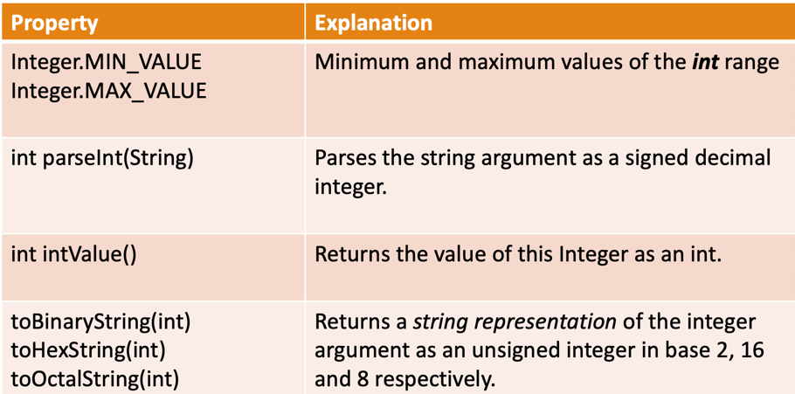
Declare olunma yontemleri:
public class test {
public static void main(String[] args) {
class IntTest {
public static void main(String args[]) {
Integer a = new Integer(5); // deprecated
Integer b = Integer.valueOf(10);
Integer c = 15;
int d = Integer.parseInt("123"); // returns int
System.out.println(a + c + b + d);
}
}
}
}

Autoboxing is the process by which a primitive type is automatically converted into its equivalent reference type (constructor is called).
Integer objNum = 15;
Auto-unboxing is the process by which the value of a boxed object is automatically converted to a primitive type (xxxValue() is called).
int x = objNum;

Non-access modifiers – static. static variables = class variables
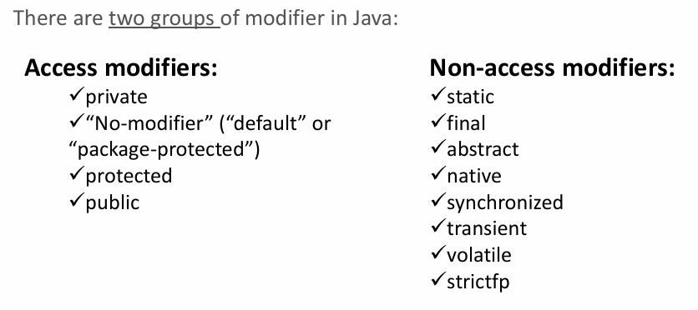
static members can be accessed both using a reference or the class name.
static methods cannot use this or super keywords.
static methods cannot access instance* variables and instance methods directly (without creating an object). Even if it is inside the same class.
class Test {
int x = 10; // instance variable

static void show() {
System.out.println(x); // ERROR
}
}

static methods can access all static variables and other static methods.
instance methods can also access static variables and static methods directly.
*Instance variables/methods are those that available when object is created.
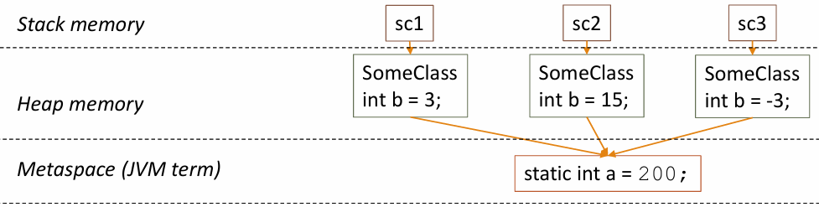
Note: private members are not DIRECTLY accessible from subclasses
class test {
private int x = 10; // instance variable

public int getX() {
return x;
}
}

class test1 extends test {
}

public class PrivateVariableAccess {
public static void main(String[] args) {
test1 obj = new test1();
System.out.println("Value of x using getX(): " + obj.getX()); // Accessing superclass variable through method
// how can we access the variable x directly in test1 class without using getX()
// method?
// We cannot access the variable x directly in test1 class because it is private
// in the superclass test. Private variables are not accessible outside the
// class they are declared in, even in subclasses.
// then how does child class use getX() method to access the value of x?
// The child class can use the getX() method to access the value of x because
// getX() is a public method in the superclass test. The child class inherits
// the getX() method, which allows it to access the value of x indirectly
// through the method. The getX() method provides a way to access the private
// variable x without directly accessing it, thus maintaining encapsulation.
}
}

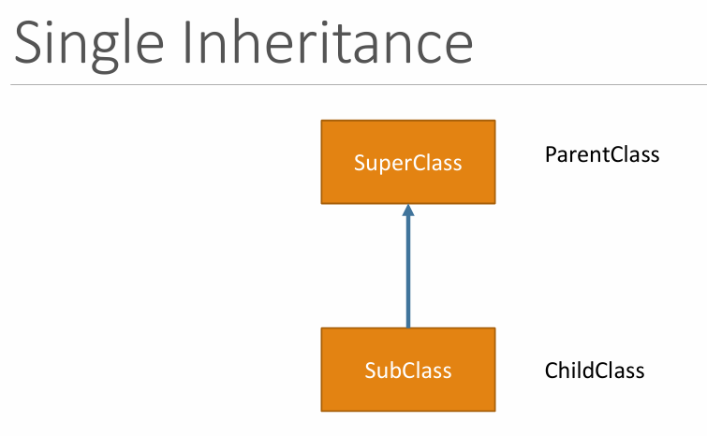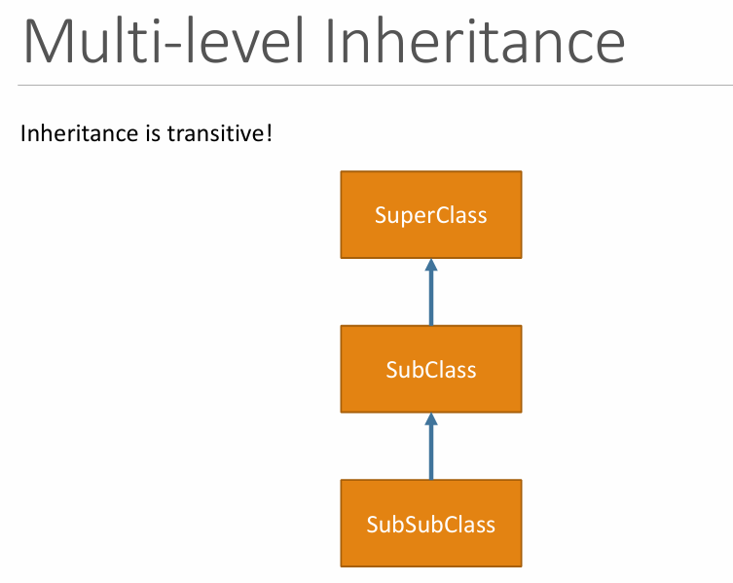
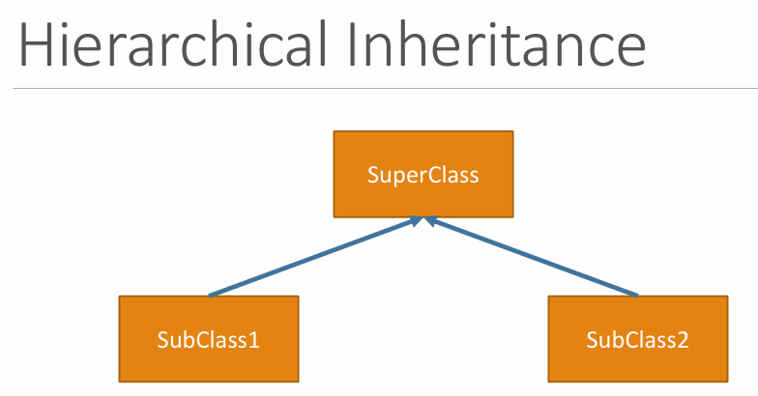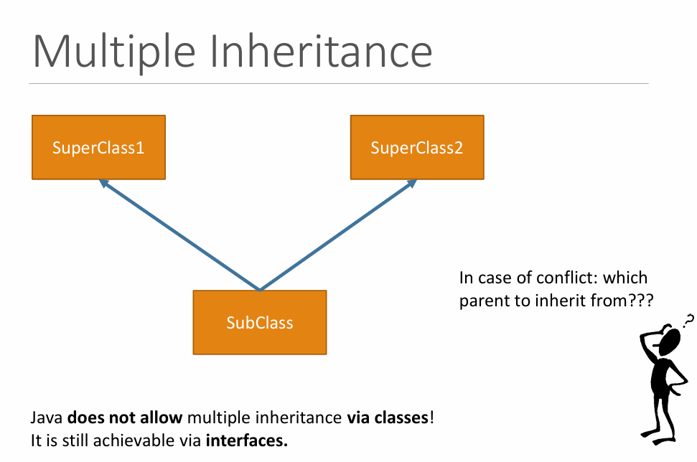
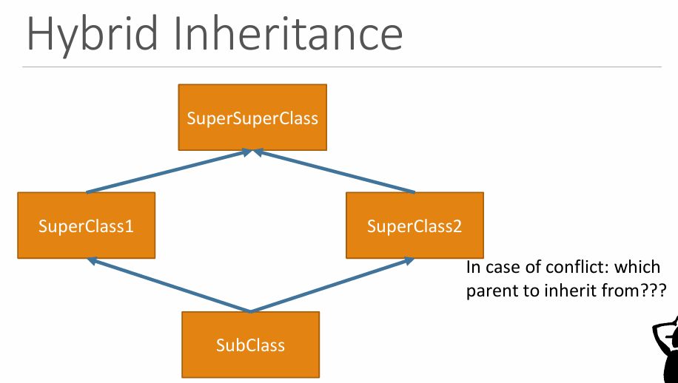
Java does not allow multiple,hybrid inheritance via classes! In case of conflict: which parent to inherit from??? It is still achievable via interfaces
Note: final class means it cannot be extended!

All accessible members, methods and constructors of the superclass can be called by super keyword.
class Shape {
private String shapeName;

public Shape(String name) {
this.shapeName = name;
}

public String getShapeName() {
return shapeName;
}
}

class Circle extends Shape {
public Circle() {
super("Circle"); // calling the constructor of the Shape class
}
}

class SuperClass {
public static void main(String[] args) {

Circle c = new Circle();
System.out.println("My name is:" + c.getShapeName()); // output: My name is: Circle
}
}

When a subclass is created, there can be two options with the constructors:
a) Subclass explicitly calls superclass’s constructor through super(…).
(1) the superclass fields will be initialized though the called constructor and then
(2) the subclass is initialized
Yeniki birinci parent classdaki constructordaki linelar execute olacaq, sonra childdaki
Numune:
class Parent {
public Parent() {
System.out.println("Parent");
}
}

class Child extends Parent {
public Child() {
super();
System.out.println("Child");
}
}
class Main {
public static void main(String[] args) {
Child child = new Child();
// Output:
// Parent
// Child
}
}

b) we don’t call super() constructor, but it implicitly is being called by compiler. But the super that’s being called is default one. So if parent class has no default constructor, then it will be error. 1st example is normal one, second one error one.

class Parent {
public Parent() {
System.out.println("Parent");
}
}

class Child extends Parent {
public Child(int x) {
// Implicit call to super() happens here, which calls the Parent constructor.
System.out.println("Child");
}
}

class Test {
public static void main(String[] args) {
Child c = new Child(5);
// Output:
// Parent
// Child
}
}

If you need to use the members or methods of super class explicitly:
class Parent {
public Parent(String s) {
System.out.println("Parent");
}
}

class Child extends Parent {
public Child(int x) {
// super() can't happen, as there is no default constructor in Parent.
System.out.println("Child");
}
}

class Test {
public static void main(String[] args) {
Child c = new Child(5);
// output: compiletime error.
}
}

class A {
public int someValue = 5;

public String getText() {
return "Some info";
}
}

class B extends A {
public String getText() {
return "Extra info";
}

public void myMethod() {
System.out.println("The value: " + super.someValue); // you can also use this.someValue, or just someValue
System.out.println("The parent method: " + super.getText()); // but here you must use super to call the parent method, otherwise it will call the child method and cause a recursive call
System.out.println("The child method: " + getText()); // or this.getText();
}

public static void main(String args[]) {
B b = new B();
b.myMethod();
// Output:
// The value: 5
// The parent method: Some info
// The child method: Extra info
}
}

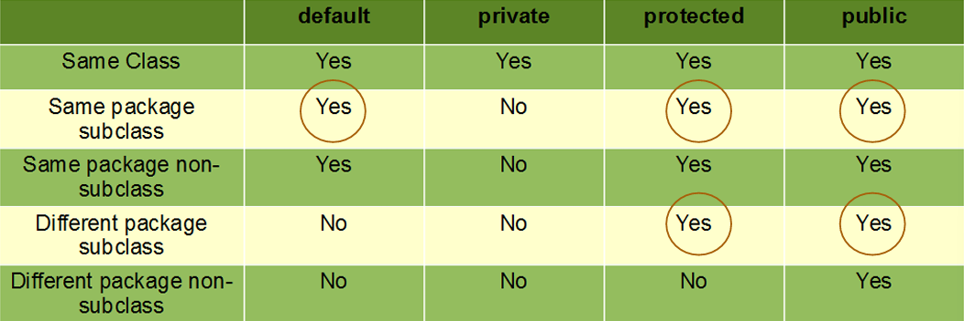

Private members of a superclass are NOT inherited by subclasses.
class A {
private int x = 3;

public void printX() {
System.out.println(x);
}
}

class B extends A {
public int x; // it has nothing to do with A.x (its value is not 3 by default)

public static void main(String args[]) {
B test = new B();
test.printX(); // but A.x can be accessed through the public method
System.out.println(test.x); // test is a ref. to object of B type, hence test.x can be accessed but it is not initialized, so it will print 0
}
}

when a method in a subclass has the same signature (name, return type and parameters) as a method in its superclass, then this method is said to override the method in the superclass.
Both override and overload is polymorphism. Override is dynamic, overload is static

Instance initialization blocks
Instance initialization blocks can access BOTH instance and static variables.
class MyClass {
int a, b;
static int c;
{ // this is an initialization block
a = 5;
c = 15;
}

public MyClass(int val) {
b = val;
}
}

Static initialization blocks
Static initialization blocks can ONLY access static variables.
class MyClass {
int a;
static int b;
static { // this is a static initialization block
a = 5; // not allowed – instance variable
b = 3; // it is OK.
}
}

There is sequence for executing initialization blocks:
1. static initialization blocks (if more than one, then in sequence) 2. initialization blocks (if more than one, then in sequence) 3. Constructor. Constructor is not considered as intialization block.
class MyClass {
int a, b;
static int c;
{ // this is an initialization block
a = 5;
c = 15;
}
static { // this is a static initialization block
c = 20;
}
MyClass(int b) {
this.b = b;
}
}

public class test {
public static void main(String[] args) {
MyClass obj = new MyClass(10);
System.out.println("a: " + obj.a); // Output: a: 5
System.out.println("b: " + obj.b); // Output: b: 10
System.out.println("c: " + MyClass.c); // Output: c: 15
}
}
